Sensory Observation & Screening Toolkit: Secondary School
How to Use This Sensory Screening Checklist
This checklist is designed to help you and the adults supporting you understand your sensory patterns across school and home. It is not a test or a diagnosis. Instead, it helps build a clearer picture of what feels challenging, what feels manageable, and what helps you regulate.
You are the expert in your own experience. This checklist simply helps organise what you already know about yourself.
Step 2
Tick what fits most of the time

Read each statement and tick the ones that sound like you. If something only happens occasionally, you can leave it. If you’re not sure, you can circle it or make a note to come back to it.

Step 1
Do it together
This checklist works best when you complete it with a trusted adult (school or home). It’s not a test, and there are no “right” answers. Take your time and be honest about what it feels like for you.

Tip: You don’t have to do it all in one go.
It can feel heavy to think about everything at once, so it’s OK to do one or two sensory systems at a time across a few sessions

Step 3
Complete the “Voice of the Young Person” worksheet
The checklist gives a snapshot. The Voice of the Young Person worksheet gives more detail. It helps you explain your sensory experiences in your own words and what helps you feel calm, safe or focused.

Step 5
Choose 2–3 priorities and make a plan

Use the “Making Sense of What You’ve Noticed” section at the end of this checklist to choose the top 2–3 areas to focus on first. Then use the Sensory Strategies Library to pick a small number of supports you’re willing to try.

Once you’ve agreed what helps, you can create the one-page Sensory Passport. This makes it easy for staff (and home) to support you consistently.

Step 4
Look for patterns and what helps

Once both documents are completed, look back together and ask:
- Which sensory systems show up the most?
- Are there certain times of day, lessons or places that are harder?
- Do things get worse when you’re tired, stressed, rushed or things feel unpredictable?
- What sensory input do you naturally seek because it helps you regulate? (This often gives good clues about strategies that may help.)

CONTENTS OF THIS CHECKLIST
Table of Contents
TACTILE SENSORY SCREENING 4
VISUAL SENSORY SCREENING 6
AUDITORY SENSORY SCREENING 8
OLFACTORY SENSORY SCREENING 10
GUSTATORY SENSORY SCREENING 12
VESTIBULAR SENSORY SCREENING 14
PROPRIOCEPTION SENSORY SCREENING 16
INTEROCEPTION SENSORY SCREENING 18
MAKING SENSE OF WHAT YOU’VE NOTICED 20

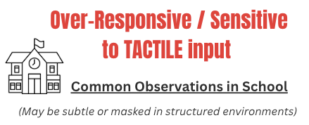  Being accidentally bumped or brushed past feels overwhelming or upsetting  Crowded corridors and moving between lessons are stressful for me  Certain uniform items or fabrics feel unbearable or distracting (labels, seams, tight clothes)  Practical subjects can feel difficult because of how materials feel (science labs, DT materials, art supplies)  Light touch from others feels more uncomfortable than firm contact  I feel dysregulated after busy lessons where there is lots of physical contact  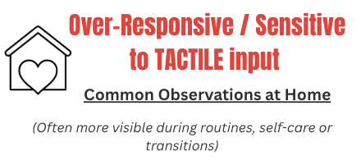  Certain clothes feel so uncomfortable that they affect my mood or concentration  Self-care tasks like showering, hair brushing or brushing my teeth feel uncomfortable or stressful  Unexpected touch from family members makes me tense or upset  I avoid physical closeness even when I care about people  I need time alone after busy days because touch feels “too much” | 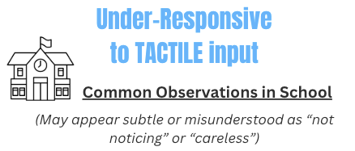  I don’t always notice when I’ve been bumped, hurt, or knocked  I don’t typically realise when my clothes are uncomfortable, twisted, or inside out  I sometimes touch objects or people without meaning to  I struggle to notice when my hands or face are dirty  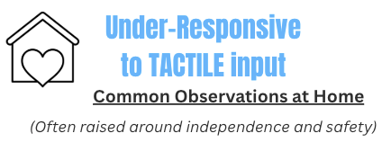  I don’t always notice cuts, bruises or minor injuries straight away  I don’t always realise when my clothes are uncomfortable, inside out, too tight or not right for the weather  I might not notice when my hands, face or clothes are dirty  I may prefer strong touch or firm pressure because light touch doesn’t register clearly  I can struggle with fine motor tasks (buttons, laces, grooming tasks)  I find it hard not to touch things, even when I know I shouldn’t
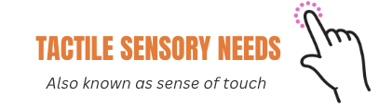

TACTILE SENSORY SCREENING

TACTILE/TOUCH – Additional Observations
This space can be used by home or school adults to add any patterns, triggers or environmental factors noticed over time.
(Consider clothing, textures, physical contact, personal space, temperature of water, self-care tasks, materials used in lessons, or how touch feels when tired or stressed.)
(Use the ‘Voice of the Young Person’ Resource to further discuss sensory preferences & challenges)
How do touch differences affect me right now?
Touch differences affect my learning or participation in school
Touch differences affect my self-care or independence at home
Touch differences affect my emotions or stress levels
I think I manage this at school, but it takes effort
Touch differences are not a big issue for me at the moment
I tend to be sensitive to touch (things feel “too much”) – Over-Responsive
I tend not to notice touch easily (I need stronger input to feel it clearly) – Under-Responsive
When Are These Needs Most Noticeable?
Touch responses can sometimes change depending on how busy things are, who is around you, what you’re wearing, or how tired you are.
More noticeable during:
(Select and add additional context as needed:) transitions / busy times / feeling rushed/ group work or times when in close proximity to others / unexpected change / self-care / fatigue / end of day
Less noticeable when:
(Select and add additional context as needed:) routines are predictable/ personal space is respected/ advance notice of touch is given / adult support is close / I feel calm & safe


VISUAL SENSORY SCREENING

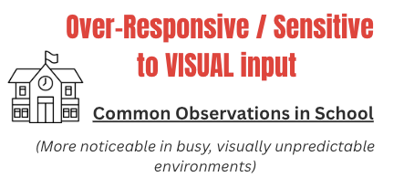  Bright lights, fluorescent lighting or flickering lights feel uncomfortable or overwhelming  Visually busy classrooms, wall displays or cluttered spaces make it hard for me to focus  Lots of movement around me (people walking past, doors opening, activity behind me) distracts or overstimulates me  Looking at the board, screens or slides for long periods feels tiring or gives me headaches  Busy corridors, assemblies or large group spaces feel visually overwhelming  Busy practical classrooms (science, DT, art) feel visually intense and hard to manage  I prefer to wear my hood up, look down, or reduce eye contact to limit visual input  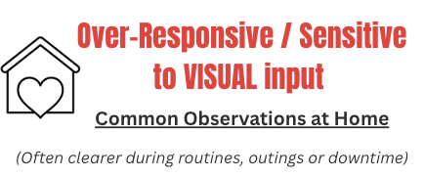  Bright lighting at home feels uncomfortable or irritating  Cluttered or busy rooms make it hard for me to relax  Busy shops or public spaces feel visually overwhelming  After school I feel visually drained and need time in a calmer space  Sudden changes to my environment make me feel unsettled | 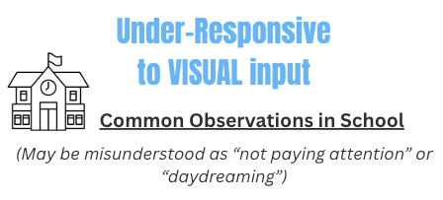  I miss information written on the board or slides  It takes me longer to process visual instructions or demonstrations  I struggle to find resources or equipment even when they are nearby  Copying from the board or textbooks is difficult for me  I do not always notice visual reminders, timetables or displays  I am drawn to bright lights, reflections or moving objects  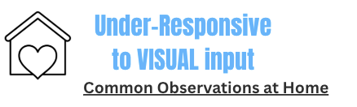  I struggle to find things even when they are in front of me  I do not always notice mess or unfinished tasks  I miss facial expressions or visual social cues  I sit very close to screens or spend long periods looking at them  I find it hard to organise homework, revision or tasks visually

VISUAL / SIGHT – Additional Observations
This space can be used by home or school adults to add any patterns, triggers or environmental factors noticed over time.
(Consider lighting, movement, visual clutter, screen use, seating position, fatigue or change.)
(Use the ‘Voice of the Young Person’ Resource to further discuss sensory preferences & challenges)
How do visual sensory differences affect me right now?
Visual differences affect my learning or participation in school
Visual differences affect my self-care or independence at home
Visual differences affect my emotions or stress levels
I think I manage this at school, but it takes effort
Visual differences are not a big issue for me at the moment
I tend to be sensitive to visual input (things feel “too much” or overwhelming) – Over-Responsive
I tend not to notice visual detail easily or need more visual input to stay alert – Under-Responsive
When Are These Needs Most Noticeable?
Visual responses can sometimes change depending on lighting, movement around you, how busy the environment is, or how tired you are.
More noticeable during:
(Select and add additional context as needed:) transitions / busy times/ when seated near to doors / unexpected change / self-care / fatigue / end of day

Less noticeable when:
(Select and add additional context as needed:) routines are predictable / adult support is close / I feel calm and safe / tasks are visually structured and uncluttered / lighting is softer or natural

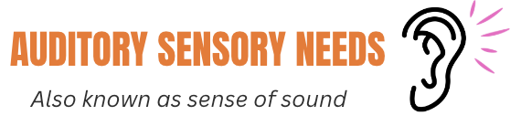
AUDITORY SENSORY SCREENING

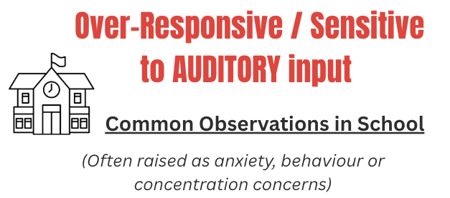  Loud or unexpected noises (e.g. bells, alarms, shouting, chairs scraping) feel overwhelming or make me anxious  Busy environments such as assemblies, dining halls or corridors feel too loud and hard to manage  I find it hard to concentrate when there is background noise or lots of people talking  Small repetitive sounds (e.g. tapping, sniffing, humming, clocks ticking) are hard for me to ignore  Eating sounds (chewing, crunching, breathing noises) make it difficult for me to stay calm or focused  I cover my ears, wear a hood or headphones, or look for ways to block out sound when it feels too much  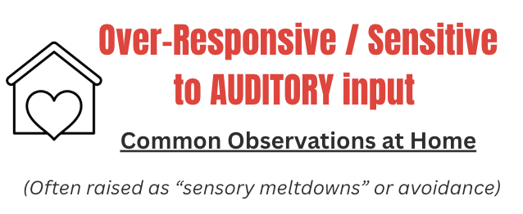  Household noise (TV, appliances, siblings, people moving around) feels overwhelming  Sudden or loud sounds (e.g. doors slamming, toilet flushing) make me panic, freeze or shut down  Busy shops, gatherings or public places feel stressful because of the noise  I need quiet time after school or busy days to recover  Noise makes it hard for me to relax, settle or sleep  I avoid certain activities or spaces because the sound feels too intense | 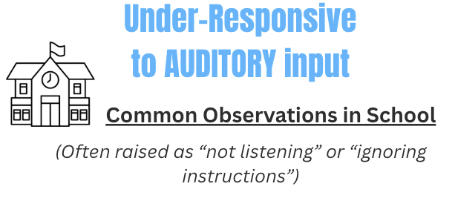  I don’t always notice when my name is called  I miss verbal instructions unless they are repeated  It takes me longer to process what someone has said  I find it hard to follow group discussions, especially when more than one person is talking  I may appear disengaged in lessons that are mostly verbal  I sometimes make noises to myself or enjoy echoing spaces where sounds are amplified  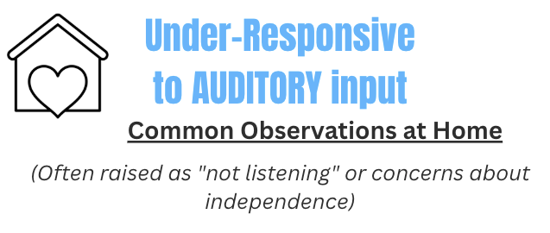  I don’t always respond when people speak to me  I need things repeated and this can frustrate others  I watch TV or listen to music very loudly  I struggle to follow spoken routines or instructions  People think I am ignoring them when I have not heard  I enjoy making sounds or being in spaces where noise echoes

AUDITORY/SOUND Additional Observations
This space can be used by home or school adults to add any patterns, triggers or environmental factors noticed over time.
(Consider noise levels, unpredictability, group size, verbal demands, fatigue, transitions or recovery time.)

(Use the ‘Voice of the Young Person’ Resource to further discuss sensory preferences & challenges)
How do auditory differences affect me right now?

Auditory differences affect my learning or participation in school
Auditory differences affect my self-care or independence at home
Auditory differences affect my emotions or stress levels
I think I manage this at school, but it takes effort
Auditory differences are not a big issue for me at the moment

I tend to be sensitive to sound (noise feels “too much” or overwhelming) – Over-Responsive
I tend not to notice sound easily or need more input to stay alert – Under-Responsive
When Are These Needs Most Noticeable?
Responses to sound can sometimes change depending on noise levels, unpredictability, how many people are talking, or how tired you are.
More noticeable during:
(Select and add additional context as needed:) transitions / busy times / unexpected loud sounds / group discussions / fatigue / after a dysregulating event / end of day
Less noticeable when:
(Select and add additional context as needed:) routines are predictable / expectations are clear in advance / adult support is close / I feel calm and safe / I have access to quieter spaces

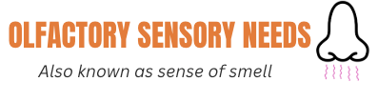
OLFACTORY SENSORY SCREENING

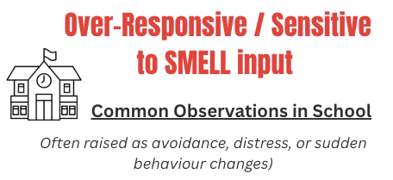  Certain smells (e.g. toilets, dining hall, science labs, food smells) make me feel overwhelmed, sick or anxious  Food smells make it hard for me to concentrate or stay in a room  Cleaning products, air fresheners or perfume feel strong, distracting or upsetting  I feel uncomfortable in certain classrooms because of how they smell  Strong smells make me want to leave the lesson or shut down  I may comment that someone smells because the odour feels overwhelming to me  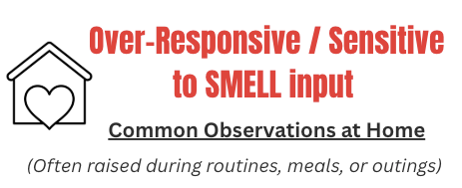  Cooking smells feel overwhelming, even if I like the food  Bathroom smells make it hard for me to use the space comfortably  Certain perfume, deodorant or cleaning products feel too strong for me  Strong smells affect my mood or make me irritable  I avoid certain rooms or activities because of how they smell  I find it hard to be near people who wear strong perfume, deodorant or have noticeable smells | 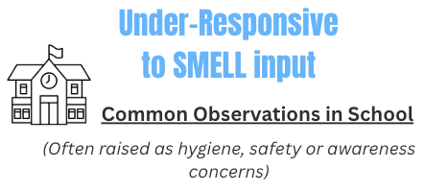  I don’t notice smells that other people react to  I don’t realise when my clothes or belongings smell  I’m not always aware of hygiene issues (e.g. body odour)  I don’t notice warning smells (e.g. burning, chemicals)  I rely on others to tell me when something smells unusual  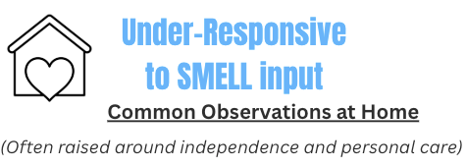  I don’t notice when clothes need washing or changing  I’m not always aware of my own body odour  I struggle to tell when food smells off or unsafe  I don’t notice when rooms smell unpleasant  I need reminders about hygiene or laundry routines

OLFACTORY/ SMELL Additional Observations
This space can be used by home or school adults to add any patterns, triggers or environmental factors noticed over time.
(Consider enclosed spaces, ventilation, proximity to others, food areas, stress levels, fatigue or transitions.)

(Use the ‘Voice of the Young Person’ Resource to further discuss sensory preferences & challenges)
How do smell differences affect me right now?
Smell differences affect my learning or participation in school
Smell differences affect my self-care or independence at home
Smell differences affect my emotions or stress levels
I think I manage this at school, but it takes effort
Smell differences are not a big issue for me at the moment

I tend to be sensitive to smells (odours feel “too much” or overwhelming) – Over-Responsive
I tend not to notice smells easily or rely on others to alert me – Under-Responsive
When Are These Needs Most Noticeable?
Responses to smells can change depending on enclosed spaces, ventilation, how close you are to others, stress levels or fatigue.
More noticeable during:
(Select and add additional context as needed:) lunchtime / dining hall / self-care routines / in enclosed or poorly ventilated spaces / unexpected smells / fatigue/end of the day
Less noticeable when:
(Select and add additional context as needed:) routines are predictable / the environment is well ventilated / I feel calm and safe / expectations are clear in advance / adult support is close

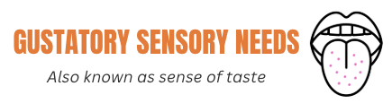
GUSTATORY SENSORY SCREENING

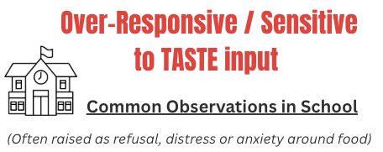  I avoid school food because the tastes feel too strong or unpredictable  Strong flavours make me feel uncomfortable, sick or overwhelmed  I struggle with foods that are mixed together or touching on the plate  Lunchtime feels stressful or anxiety-provoking because of food expectations  I avoid food-related lessons or activities because I feel pressured to taste  Unexpected changes to food (brand, recipe, temperature) make it hard for me to eat  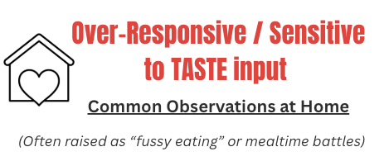  I eat a small range of foods because many tastes feel unpleasant  Being asked to “just try” foods makes me anxious or upset  Certain flavours make me gag or feel overwhelmed  Mealtimes feel stressful or emotionally draining  If a safe food tastes slightly different, I may stop eating it | 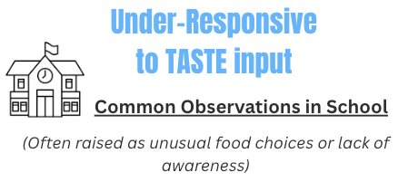  I prefer very strong flavours or spicy foods to feel satisfied  I add lots of sauce, seasoning or flavouring to food  I don’t always notice when food tastes bland or unusual  I may eat quickly without noticing taste  I put non-food items in my mouth without thinking  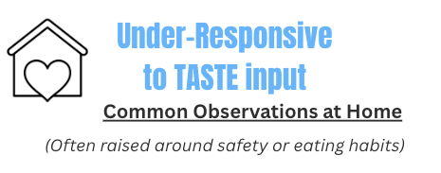  I prefer very strong, sour, spicy or intense flavours  I seek out chewy or crunchy foods for extra sensory input  I eat quickly and don’t always notice when I’m full  I may over-season food without realising  I don’t always notice when food is too hot in temperature
GUSTATORY/TASTE Additional Observations
This space can be used by home or school adults to add any patterns, triggers or environmental factors noticed over time.
(Consider predictability, social expectations, food presentation, pressure to try new foods, stress levels or fatigue.)

(Use the ‘Voice of the Young Person’ Resource to further discuss sensory preferences & challenges)
How do taste differences affect me right now?

Taste differences affect my learning or participation in school
Taste differences affect my self-care or independence at home
Taste differences affect my emotions or stress levels
I think I manage this at school, but it takes effort
Taste differences are not a big issue for me at the moment

I tend to be sensitive to taste (flavours feel “too much” or overwhelming) – Over-Responsive
I tend to need stronger flavours or more intense taste to notice it clearly – Under-Responsive
When Are These Needs Most Noticeable?
Responses to food and taste can vary depending on stress levels, predictability, social demands and fatigue. Consider when eating becomes more restricted or challenging, and what this may suggest about environmental load or emotional regulation
More noticeable during:
(Select and add additional context as needed lunchtime in busy dining halls / unfamiliar foods / social eating situations / after a dysregulating event / when rushed / when tired
Less noticeable when:
(Select and add additional context as needed routines are predictable / preferred foods are available / eating takes place in a calm or quieter space / adult support is close / there is no pressure to try new foods


VESTIBULAR SENSORY SCREENING

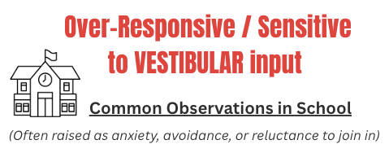  PE lessons or fast-paced movement activities make me feel anxious or overwhelmed  Busy corridors and rushing between lessons make me feel unsettled or off balance  I feel uncomfortable when my feet leave the ground or when I am not fully stable  I avoid stairs, slopes or crowded stairwells because they feel unsafe  I feel anxious using lifts, escalators or walking on uneven surfaces  After busy movement-heavy lessons, I feel dysregulated, tired or irritable  I feel anxious or unsafe sitting on high stools or chairs where my feet are not firmly on the floor  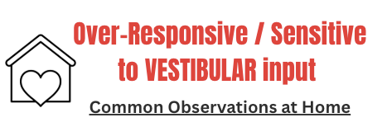  Activities like fairground rides or spinning feel too intense  Car journeys, buses or trains make me feel nauseous or unwell  Washing my hair or tipping my head back feels uncomfortable or stressful  I feel anxious on heights, balconies or open staircases  After busy days with lots of movement, I feel overwhelmed  Bending forward to tie my shoelaces or pick something up makes me feel uncomfortable or off balance | 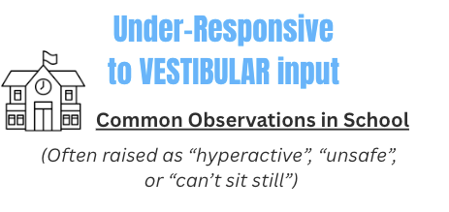  I find it hard to stay seated and often need to move  I fidget, rock, bounce or shift position when sitting  I lean on walls, furniture or people when standing  I seek out spinning, running or fast movement  I struggle with balance, coordination or gross motor tasks  I find it hard to negotiate busy school spaces safely  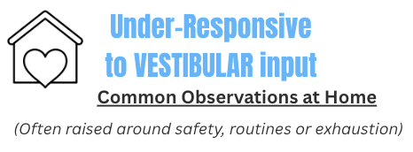  I am often in motion and find it hard to sit still  I seek out bouncing, spinning or rough movement  I slump, lean or struggle to maintain upright posture  I have poor balance or coordination in everyday tasks  I bump into things or misjudge distances
VESTIBULAR Additional Observations
This space can be used by home or school adults to add any patterns, triggers or environmental factors noticed over time.
(Consider transitions, changes in pace, crowded environments, uneven surfaces, fatigue or recovery time.)

(Use the ‘Voice of the Young Person’ Resource to further discuss sensory preferences & challenges)

How do movement differences affect me right now?

Movement differences affect my learning or participation in school
Movement differences affect my self-care or independence at home
Movement differences affect my emotions or stress levels
I think I manage this at school, but it takes effort
Movement differences are not a big issue for me at the moment

I tend to be sensitive to movement (motion feels overwhelming or unsafe) – Over-Responsive
I tend to need more movement or struggle to stay still – Under-Responsive
When Are These Needs Most Noticeable?
Vestibular responses (movement and balance) can vary depending on transitions, changes in pace, environmental movement and levels of predictability.
More noticeable during:
(Select and add additional context as needed:) transitions / busy environments / lining up / sudden movement / after a dysregulating event / when rushed / when tired

Less noticeable when:
(Select and add additional context as needed:) routines are predictable / movement expectations are explained in advance / adult support is close / I feel safe / movement is self-directed and controlled


PROPRIOCEPTION SENSORY SCREENING

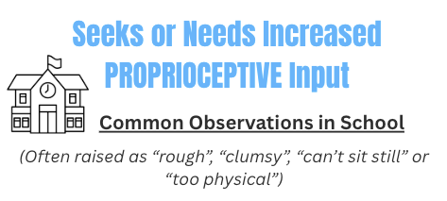  I find it hard to stay seated and often lean, rock, tip my chair or shift position during lessons  I slump on the desk, rest my head on my hands, or wrap myself into my chair to feel supported  I bump into desks, doorways or people without meaning to  I misjudge personal space and may stand too close or brush past others  I use too much or too little force when writing, colouring, cutting or using tools  My handwriting can look messy because I struggle to control pressure or speed  I fidget with my hands a lot (picking skin, pulling sleeves, cracking knuckles) to get body input  I chew hoodie strings, pens, nails or objects when concentrating or stressed  I press hard on the table, squeeze items, or “heavy lean” when working  I can seem too rough in PE, practical lessons or group work and may hurt others accidentally  When I feel dysregulated, I may slam objects, bang my bag, or punch walls/doors without thinking  I find changing for PE difficult because my body feels awkward, clumsy or hard to organise | 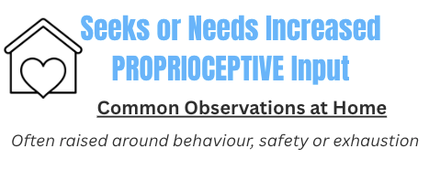  I seek strong hugs, pressure or being “squashed” to feel calm  I like weighted experiences (heavy blankets, weighted lap pads, heavy hoodies)  I prefer tight or heavier clothing (hood up, snug layers) because it helps me feel held together  I chew clothing, hoodie strings, fingers or objects when I’m concentrating, stressed or bored  I pick at skin, bite nails, crack knuckles or fiddle with my body to get input  I jump, crash, stomp, slam doors or use more force than I realise  I lean heavily on furniture, walls or people when standing or walking around  I struggle to calm down unless I move my body or get deep pressure  I can accidentally hurt others during play because I misjudge my strength  When I’m dysregulated I might throw objects, hit things, or punch walls/cushions  I find fine motor tasks hard (buttons, laces, hair, opening packets)  I seem clumsy, drop things, knock drinks over, or misjudge where my body is
Proprioceptive input (body awareness, deep pressure and muscle activity) is typically regulating for most people. Difficulties are more commonly linked to under-registration, force grading or a need for additional input rather than sensitivity.
PROPRIOCEPTION Additional Observations
This space can be used by home or school adults to add any patterns, triggers or environmental factors noticed over time.
(Consider long periods of sitting, transitions, crowded environments, fatigue, stress levels, recovery time or access to movement.)

(Use the ‘Voice of the Young Person’ Resource to further discuss sensory preferences & challenges)
How do proprioception differences affect me right now?

Proprioception differences affect my learning or participation in school
Proprioception differences affect my self-care or independence at home
Proprioception differences affect my emotions or stress levels
I think I manage this at school, but it takes effort
Proprioception differences are not a big issue for me at the moment

I tend to need more proprioceptive input (deep pressure, heavy work or muscle input) to feel regulated
When Are These Needs Most Noticeable?
Proprioceptive responses (body awareness, muscle input and force control) can vary depending on movement opportunities, environmental demands and levels of fatigue or stress.
More noticeable during:
(Select and add additional context as needed:) long periods of seated work / busy transitions / fine motor tasks requiring control / after a dysregulating event / when rushed or under time pressure / when tired

Less noticeable when:
(Select and add additional context as needed:) routines are predictable / movement opportunities are built in / expectations are clear in advance / adult support is close / activities involve heavy work or structured movement



INTEROCEPTION SENSORY SCREENING

Interoception is how we notice signals from inside the body (e.g. hunger, thirst, needing the toilet, tiredness, temperature, pain, illness and emotions). Some signals may feel very loud or urgent, while others may be quiet or hard to notice. You may experience different patterns across different body signals.
  I notice hunger or thirst really quickly and it feels urgent or distracting  If I’m not allowed to eat or drink straight away, I get irritable, anxious or shaky and it’s hard to think clearly.  I can go most of the school day without realising I’m hungry or thirsty, then suddenly feel dizzy, angry or overwhelmed.  When I’m gaming, or focused on something, I forget to eat or drink until someone reminds me. |   When I feel the need to use the toilet, it feels sudden and urgent and I worry about not getting there in time.  I’m often worried or thinking about if I need to go to the toilet  I don’t notice I need the toilet until it feels urgent or uncomfortable.  I ignore the feeling and stay in class because I feel too worried to ask
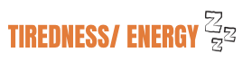  If I feel even slightly tired, everything feels harder (noise is louder, work feels impossible, I get snappy).  After a busy school day, I feel completely drained and can’t cope with homework or conversation.  I don’t realise I’m tired until I suddenly shut down, get emotional or argue with people.  I stay up late on my phone or gaming because I don’t feel tired - then I crash the next day. |   If a classroom or space is too hot or too cold, I can’t concentrate and feel uncomfortable or stressed.  Small temperature changes (e.g. going outside then back in) affect my mood more than other people’s.  I don’t notice I’m too hot or cold until someone points it out.  I forget to adjust my clothing (e.g. still wearing a hoodie in heat, no coat in winter).
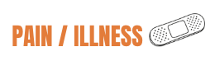  Minor aches (headaches, tummy aches, heart beating fast) feel intense and worrying.  I focus on small body sensations and worry something is wrong.  I don’t notice injuries (cuts, bruises, sprains) until they’re pointed out.  I carry on even when unwell because I don’t recognise early signs. | 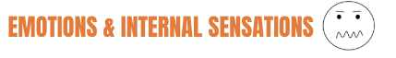  Strong emotions hit fast and feel huge (e.g. embarrassment feels unbearable, anger feels explosive).  When my heart races or my chest feels tight, I think something is wrong and panic.  My emotional reactions seem to come “out of nowhere” - I don’t notice build-up.  I find it hard to explain what I’m feeling until it becomes intense or I’m already upset.
(Use the ‘Voice of the Young Person’ Resource to further discuss sensory preferences & challenges)
How do interoception differences affect me right now?

Interoception differences affect my learning or participation in school
Interoception differences affect my self-care or independence at home
Interoception differences affect my emotions or stress levels
I think I manage this at school, but it takes effort
Interoception differences are not a big issue for me at the moment

I tend to experience my internal signals as “loud” (they feel intense or overwhelming)
I tend to experience my internal signals as “quiet” (they are hard to notice until they become extreme)

When Are These Needs Most Noticeable?
Interoceptive awareness can vary depending on stress levels, fatigue, predictability and environmental demands. Consider when internal signals become more overwhelming or harder to notice.
Interoception difficulties are more noticeable during:
(Select and add additional context as needed:) busy or demanding times / when routines change / after emotional stress / when I’m tired / in unfamiliar environments / when I’m focused on something and miss early body signals
Interoception difficulties are less noticeable when:
(Select and add additional context as needed:) routines are predictable / body check-ins are built into the day / adults respond calmly and consistently / I feel safe / my physical needs are prompted or anticipated


MAKING SENSE OF WHAT YOU’VE NOTICED

What Have We Noticed About My Sensory Patterns?
Looking across all the sensory systems, these are the patterns that stand out most for me:
I’m more sensitive in unpredictable or busy environments  I need a lot of movement, pressure or physical input to feel regulated  I don’t always notice my internal signals until they’re intense  Sensory needs increase when I’m tired  I mask or push through at school  My sensory needs affect my emotions  My sensory needs affect my learning  My sensory needs affect my independence at home | OR..  Key patterns we’ve noticed together:

Which Sensory Systems Are Currently Impacting Me Most?
Select up to 3 priority areas:
Tactile
Visual
Auditory
Olfactory
Gustatory
Vestibular (movement & balance)
Proprioception (body awareness & pressure)
Interoception (body awareness & pressure)

When Is My Day Hardest?
If sensory overload builds up across the day, it helps to identify when things feel most difficult. This is often the best place to start.
Morning routine (before school)
Journey to school
Arriving at school
Morning lessons
Break time
Lunchtime
Afternoon lessons
End of day / leaving school
After school / evening
Bedtime

What is happening at this time that makes it hard? (Noise? Social pressure? Hunger? Fatigue? Movement? Unpredictability?)

Our Plan: 2–3 Priorities to Try First

Choose 2–3 High-Impact Priorities
When we focus on two or three high-impact sensory needs, things often improve across the whole day. Small changes can make a big difference.
Start where:
• The impact feels biggest for you
• You experience the most stress
• A small change could help quickly
Small environmental shifts often create significant change.

Priority 1:
What is the sensory need?  (What feels hardest right now?) | (e.g. auditory overwhelm during lunchtime)
When does this usually happen? | (Be specific: part of day, setting, trigger)
What happens when it builds up? | (e.g. I shut down / I argue / I leave / I feel anxious / I can’t focus)
What small change will we try first? | Use the Sensory Strategies Library for ideas..
What do I need to do to make this strategy work?  (What will I try? What will I practise? What will I remember to do?) | (e.g: I will use the strategy at X time, I will give it a fair try for X weeks, I will use the agreed signal or system , I will return to learning after using the strategy)
What do adults need to do to help this work?  (What support, reminders or adjustments will help me succeed?) | (e.g: remind me to use the strategy, follow the plan consistently, be discreet, review together if it's not working)
What will be different if this works?? | (What will I be able to do that’s hard right now?)
How will we know it’s helping? | (What will adults notice? What will I notice?)
Review date: | 01/01/26

Priority 2:
What is the sensory need?  (What feels hardest right now?) | (e.g. auditory overwhelm during lunchtime)
When does this usually happen? | (Be specific: part of day, setting, trigger)
What happens when it builds up? | (e.g. I shut down / I argue / I leave / I feel anxious / I can’t focus)
What small change will we try first? | Use the Sensory Strategies Library for ideas..
What do I need to do to make this strategy work?  (What will I try? What will I practise? What will I remember to do?) | (e.g: I will use the strategy at X time, I will give it a fair try for X weeks, I will use the agreed signal or system , I will return to learning after using the strategy)
What do adults need to do to help this work?  (What support, reminders or adjustments will help me succeed?) | (e.g: remind me to use the strategy, follow the plan consistently, be discreet, review together if it's not working)
What will be different if this works?? | (What will I be able to do that’s hard right now?)
How will we know it’s helping? | (What will adults notice? What will I notice?)
Review date: | 01/01/26

Priority 1:
What is the sensory need?  (What feels hardest right now?) | (e.g. auditory overwhelm during lunchtime)
When does this usually happen? | (Be specific: part of day, setting, trigger)
What happens when it builds up? | (e.g. I shut down / I argue / I leave / I feel anxious / I can’t focus)
What small change will we try first? | Use the Sensory Strategies Library for ideas..
What do I need to do to make this strategy work?  (What will I try? What will I practise? What will I remember to do?) | (e.g: I will use the strategy at X time, I will give it a fair try for X weeks, I will use the agreed signal or system , I will return to learning after using the strategy)
What do adults need to do to help this work?  (What support, reminders or adjustments will help me succeed?) | (e.g: remind me to use the strategy, follow the plan consistently, be discreet, review together if it's not working)
What will be different if this works?? | (What will I be able to do that’s hard right now?)
How will we know it’s helping? | (What will adults notice? What will I notice?)
Review date: | 01/01/26
Next Steps
Once this plan has been completed (alongside the Voice of the Young Person worksheet), use the information gathered to create a clear, one-page Sensory Passport.
This passport should summarise:
- The young person’s key sensory patterns
- The top priority needs
- Agreed strategies and supports
- What helps them feel regulated, safe and ready to learn
The Sensory Passport should be shared with relevant teaching and support staff so that strategies are applied consistently across lessons and settings.
Consistency matters. Sensory strategies are most effective when they are understood and used in the same way by all adults supporting the young person.
Review the passport regularly and update it as needs change.

