Sensory Observation & Screening Toolkit
Primary School

How to Use This Sensory Screening Checklist
This checklist is designed to help adults notice patterns in a child’s sensory experiences across home and school. It is not a diagnostic tool. Instead, it supports structured observation and shared understanding.
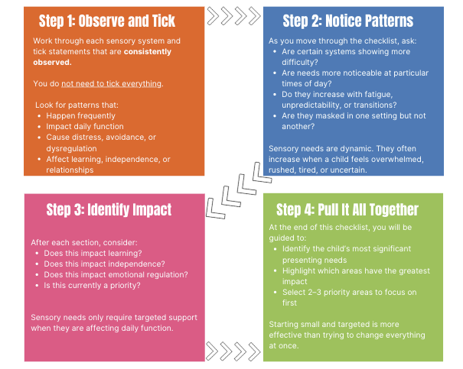

CONTENTS OF THIS CHECKLIST
Table of Contents
TACTILE SENSORY SCREENING 4
VISUAL SENSORY SCREENING 6
AUDITORY SENSORY SCREENING 8
OLFACTORY SENSORY SCREENING 10
GUSTATORY SENSORY SCREENING 12
VESTIBULAR SENSORY SCREENING 14
PROPRIOCEPTION SENSORY SCREENING 16
INTEROCEPTION SENSORY SCREENING 18
MAKING SENSE OF WHAT YOU’VE NOTICED 20

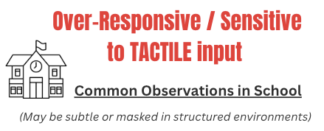  Becomes distressed when accidentally bumped or touched by others  Finds lining up, carpet time or group work difficult due to close proximity  Avoids messy play (paint, glue, sand, food textures)  Becomes upset if hands feel dirty or sticky  Finds certain clothing or uniform uncomfortable (labels, seams, socks)  Reacts strongly to light touch from peers  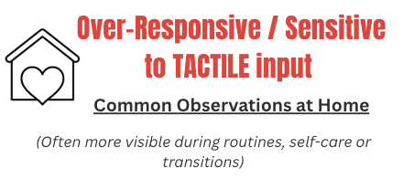 Appears dysregulated after busy or physical parts of the day  Becomes distressed during dressing or undressing  Difficulty brushing teeth  Difficulty getting in or out of the shower – drying  Dislikes having hair brushed/ cut  Difficulty cutting nails  Avoids certain food textures or dislikes food touching  Becomes upset by unexpected touch from siblings or adults | 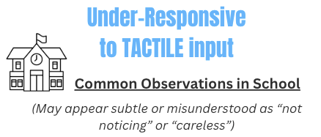  Does not notice when hands, face or clothes are dirty  Appears unaware of bumps, knocks or minor injuries  Touches objects, people or surfaces frequently  Struggles with personal boundaries and may touch others without noticing  Does not notice wet clothes, food on skin, or sticky hands  Does not seem to notice when clothes are twisted or inside out  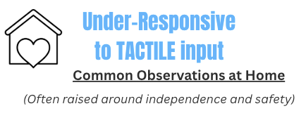  Messy eating without awareness of food on face or hands  Does not notice when clothes are twisted, inside out or uncomfortable  High tolerance for hot or cold water  Enjoys getting very messy and may not recognise when to stop  Seeks strong tactile input (crashing, squeezing, rough play)  Displays strong urge to touch everything when out in public eg: touching items in shops, trailing fingers along walls.
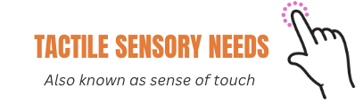

TACTILE SENSORY SCREENING

TACTILE/ TOUCH Preferences | TACTILE/TOUCH Challenges
- Calming touch experiences  - Childs favourite items to touch  - Comfort items  - Seeks more of..  Write touch preferences here... | - Triggers  - Avoids  - Tricky sensations  Write touch challenges here...

Because of Tactile sensory needs, this child currently struggles with…
Tactile needs impact learning and participation in school
Tactile needs impact self-care or independence at home
Tactile needs impact emotional regulation
Tactile needs appear masked in school
Tactile needs are not currently a priority (they may exist, but not impacting daily function)
Appears to present over-responsive to tactile input
Appears to present under-responsive to tactile input
When Are These Needs Most Noticeable?
Responses to touch can vary depending on proximity to others, clothing demands, environmental busyness and overall stress or fatigue. Consider when sensitivity to touch or need for additional touch input increases or reduces, and what this may suggest about predictability, personal space or regulation.
More noticeable during:
(Select and add additional context as needed:) transitions / busy times / feeling rushed/ group work or times when in close proximity to others / unexpected change / self-care / fatigue / end of day
Less noticeable when:
(Select and add additional context as needed:) routines are predictable/ personal space is respected/ advance notice of touch is given / adult support is close / child feels safe


VISUAL SENSORY SCREENING

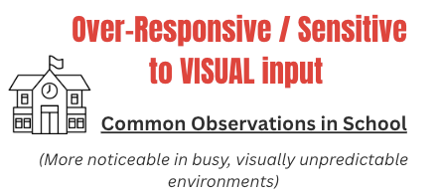  Becomes overwhelmed or anxious in visually busy classrooms  Struggles to focus when walls are covered with displays or bright visuals  Avoids looking at the board or appears visually “shut down” during teaching input  Becomes unsettled by movement around them (children walking past, lining up nearby)  Finds assemblies, corridors or dining halls overwhelming  Appears anxious or dysregulated during transitions  Squints, turns away, or covers eyes in bright lighting  Becomes fatigued or dysregulated after visually demanding tasks (copying, scanning worksheets)  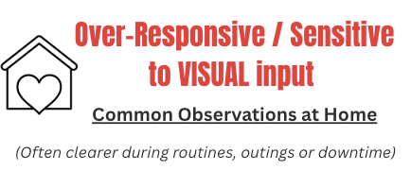  Becomes overwhelmed in cluttered or visually busy rooms  Dislikes bright lights and prefers dimmer environments  Finds busy shops or public places distressing  Becomes unsettled when furniture, rooms or routines change  Struggles to settle at the end of the day  Appears irritable or withdrawn after busy days | 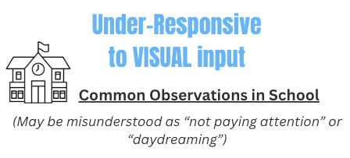  Misses information written on the board or displayed in the classroom  Appears slow to respond to visual instructions or demonstrations  Struggles to locate resources or belongings in front of them  Has difficulty copying from the board or scanning worksheets  Does not notice visual cues (signals, gestures, visual timetables)  Appears disengaged during visually presented lessons  Bumps into furniture or peers in busy spaces  Relies heavily on adult prompts to stay on task  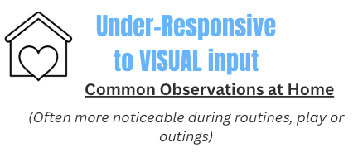  Does not notice mess, toys or items around them  Struggles to find items even when they are in plain sight  Does not notice mismatched, inside-out or untidy clothing  Watches TV or uses screens very closely  Misses visual social cues (facial expressions, gestures)  Needs repeated reminders to complete routines

VISUAL/SIGHT Preferences | VISUAL/SIGHT Challenges
- Calming visual experiences  - Childs favourite items to look at  - Seeks more of..  Write visual preferences here... | - Triggers  - Avoids  - Tricky visually busy environments  Write visual challenges here...

Because of Visual Sensory needs, this child currently struggles with…
Visual needs impact learning and participation in school
Visual needs impact self-care or independence at home
Visual needs impact emotional regulation
Visual needs appear masked in school
Visual needs are not currently a priority (they may exist, but not impacting daily function)
Appears to present over-responsive to visual input
Appears to present under-responsive to visual input
When Are These Needs Most Noticeable?
Responses to visual input can vary depending on light levels, movement in the environment, visual clutter and overall stress or fatigue. Consider when visual sensitivity, distraction or avoidance increases or reduces, and what this may suggest about environmental demands or predictability.
More noticeable during:
(Select and add additional context as needed:) transitions / busy times/ when seated near to doors / unexpected change / self-care / fatigue / end of day
Less noticeable when:
(Select and add additional context as needed:) routines are predictable / adult support is close / child feels safe/ tasks are visually structured and uncluttered / lighting is softer or natural

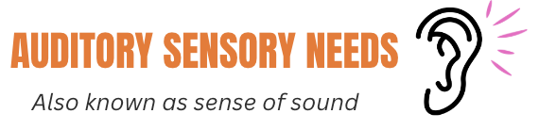
AUDITORY SENSORY SCREENING

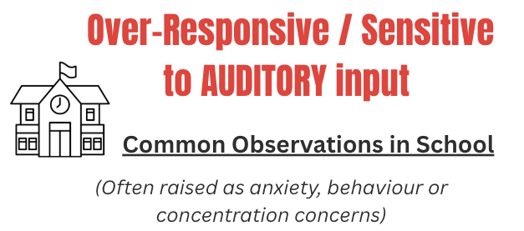  Becomes distressed or upset by loud or unexpected noises (bells, chairs scraping, shouting)  Struggles to concentrate in noisy classrooms  Finds assemblies, dining hall or PE hall overwhelming  Becomes anxious before known noisy times of day (lunch, assemblies, transitions)  Covers ears, cries or withdraws when noise levels increase  Appears tired, irritable or dysregulated after noisy periods  Finds group work difficult due to multiple voices  Notices background noises others don’t and is distracted by this  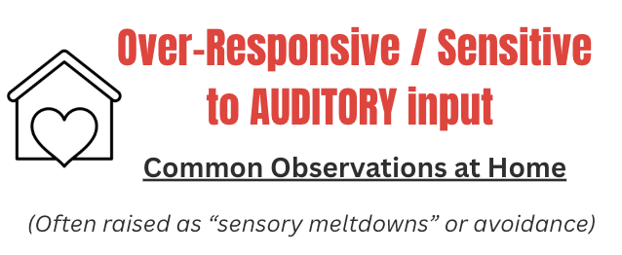  Becomes distressed by household noises (hoover, TV, siblings)  Finds busy places (shops, cafés, family gatherings) overwhelming  Becomes upset by sudden or high-pitched sounds  Appears irritable or withdrawn after noisy outings  Struggles to settle at the end of the day  Notices background noises others don’t and is distressed by this | 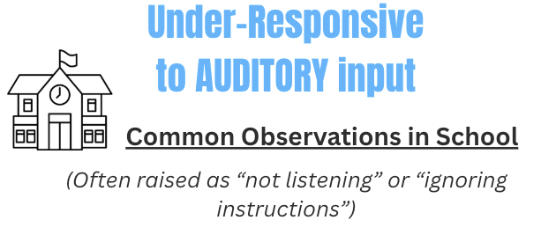  Does not respond when their name is called  Misses verbal instructions unless they are repeated  Appears unaware of background noise or loud environments  Struggles to follow group discussions or carpet-time input  Appears slow to process spoken information  Appears disengaged during verbally led lessons  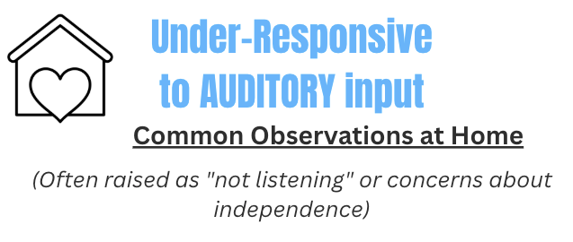  Does not respond when spoken to unless approached closely  Needs instructions repeated many times  Does not notice alarms, timers or background sounds  Watches TV or listens to devices at high volume  Appears “in their own world” during conversations

AUDITORY/SOUND Preferences | AUDITORY/SOUND Challenges
- Calming/preferred sounds  - Childs favourite sounds to listen to  - Seeks more of..  Write sound preferences here... | - Triggers  - Avoids  - Tricky noises/ environments  Write sound challenges here...

Because of Auditory Sensory needs, this child currently struggles with…
Auditory needs impact learning and participation in school
Auditory needs impact self-care or independence at home
Auditory needs impact emotional regulation
Auditory needs appear masked in school
Auditory needs are not currently a priority (they may exist, but not impacting daily function)
Appears to present over-responsive to auditory input
Appears to present under-responsive to auditory input
When Are These Needs Most Noticeable?
Responses to sound can vary depending on noise levels, verbal demands, unpredictability and overall stress or fatigue. Consider when listening, sound tolerance or verbal processing becomes more difficult, and what this may suggest about environmental load or predictability.
More noticeable during:
(Select and add additional context as needed:) transitions / busy times / unexpected change / Fire alarms or sudden noises / fatigue / after a dysregulating event / end of day
Less noticeable when:
(Select and add additional context as needed:) routines are predictable/ When expectations are clear in advance/ adult support is close / child feels safe / preferred activity with a clear start & end

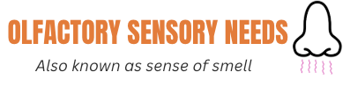
OLFACTORY SENSORY SCREENING

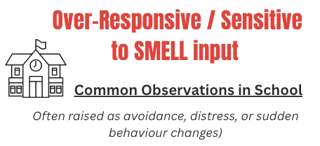  Becomes distressed or refuses to enter certain spaces because of smells (toilets, dining hall, classrooms)  Reacts strongly to food smells in the classroom or dining hall  Becomes unsettled by cleaning products, air fresheners or staff perfume  Appears nauseous, gags or becomes tearful when exposed to certain smells  Struggles to concentrate when unpleasant smells are present  Avoids practical activities due to smell (art materials, glue, cooking activities)  Tells peers or adults that they smell, leading to social difficulties  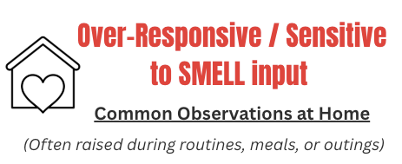  Refuses certain foods because of the smell  Becomes distressed by household smells (cooking, bins, pets)  Avoids bathrooms or toilets due to smells  Reacts strongly to perfume, deodorant or washing products  Appears irritable or overwhelmed in public places with strong smells  Tells peers or adults that they smell, leading to social difficulties | 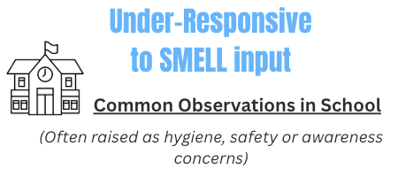  Does not notice unpleasant smells that others react to  Does not notice when food, clothes or belongings smell unpleasant  Appears unaware of hygiene issues (body odour, toileting accidents)  Does not notice strong smells that indicate risk (burning, chemicals)  Attempts to smell cleaning products, chemicals or other unsafe substances  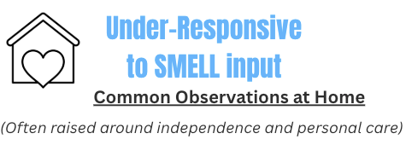  Does not notice when clothes need changing or washing  Appears unaware of body odour  Does not react to strong or unpleasant household smells  Attempts to smell cleaning products, chemicals or other unsafe substances

OLFACTORY/SMELL Preferences | OLFACTORY/SMELL Challenges
- Calming/preferred smells  - Childs favourite smells..  - Seeks more of..  Write smell preferences here... | - Triggers  - Avoids  - Tricky smells/ environments  Write smell challenges here...
Because of Smell Sensory needs, this child currently struggles with…
Smell needs impact learning and participation in school
Smell needs impact self-care or independence at home
Smell needs impact emotional regulation
Smell needs appear masked in school
Smell needs are not currently a priority (they may exist, but not impacting daily function)
Appears to present over-responsive to smell input
Appears to present under-responsive to smell input
When Are These Needs Most Noticeable?
Responses to smell can vary depending on proximity to others, enclosed spaces, environmental changes and levels of stress or fatigue. Consider when reactions to smells increase or reduce, and what this may suggest about predictability, ventilation or emotional regulation.
More noticeable during:
(Select and add additional context as needed:) lunchtime / dining hall / self-care routines / in enclosed or poorly ventilated spaces / unexpected smells / fatigue/end of the day
Less noticeable when:
(Select and add additional context as needed:) routines are predictable/ When expectations are clear in advance/ adult support is close / child feels safe/ The environment is well ventilated/ Outdoors

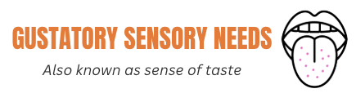
GUSTATORY SENSORY SCREENING

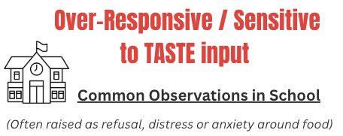  Refuses school dinners or avoids eating at school  Becomes distressed by strong tastes or flavours  Struggles with mixed foods or foods touching  Avoids tasting activities in lessons (e.g. cooking, food technology, cultural days)  Gags or becomes upset when encouraged to try new foods  Finds lunchtime overwhelming due to taste, smell and noise combined  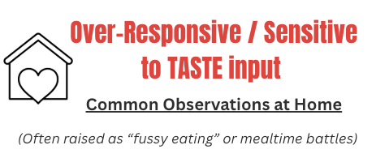  Eats a very limited range of foods  Refuses foods based on taste even if appearance seems acceptable  Becomes distressed when asked to try new foods  Prefers bland or specific flavours  Prefers bland or specific flavours  Brushing teeth is tricky due to the toothpaste being too minty or “spicy” | 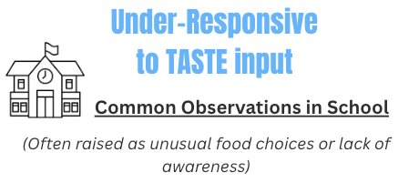  Seeks strong flavours (very salty, spicy, sour)  Overfills mouth or eats very quickly  Does not notice when food is too hot or cold  Appears unaware of food residue on face or in mouth  Eats non-food items or mouths objects  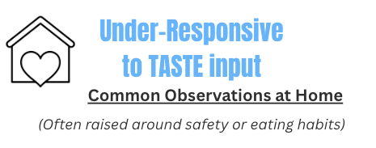  Eats very spicy, strong or intense flavours without noticing  Does not recognise when food is too hot or unsafe  Appears unaware of tastes that others find unpleasant  Eats non-food items or mouths objects
GUSTATORY/TASTE Preferences | GUSTATORY/TASTE Challenges
- Calming/preferred tastes  - Childs favourite food/ drinks  - Safe foods  - Seeks more of..  Write taste preferences here... | - Triggers  - Avoids  - Most disliked foods  Write taste challenges here...
Because of Taste Sensory needs, this child currently struggles with…
Taste needs impact learning and participation in school
Taste needs impact self-care or independence at home
Taste needs impact emotional regulation
Taste needs appear masked in school
Taste needs are not currently a priority (they may exist, but not impacting daily function)
Appears to present over-responsive to taste input
Appears to present under-responsive to taste input
When Are These Needs Most Noticeable?
Responses to food and taste can vary depending on stress levels, predictability, social demands and fatigue. Consider when eating becomes more restricted or challenging, and what this may suggest about environmental load or emotional regulation
More noticeable during:
(Select and add additional context as needed:) Lunchtime in busy or noisy dining halls / When routines change / Unfamiliar foods/ Social eating situations / After a dysregulating event earlier in the day/ When rushed or time-limited/ When tired / In unfamiliar environments
Less noticeable when:
(Select and add additional context as needed:) Routines are predictable/ Preferred foods are available/ Eating takes place in a calm or quieter space/ Adult support is close/ The child feels safe/ There is no pressure to try new foods/ Eating happens at a consistent time


VESTIBULAR SENSORY SCREENING

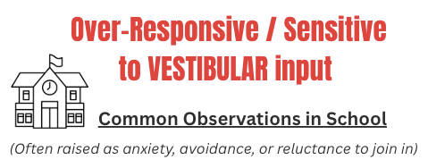  Becomes anxious or distressed during PE or movement games  Avoids playground equipment (climbing frames, swings, slides)  Becomes distressed when feet leave the ground  Finds lining up, rushing or busy transitions unsettling  Appears fearful of falling or losing balance  Becomes dysregulated after movement-heavy parts of the day  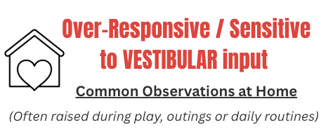  Avoids bikes, scooters, swings or soft play (or is overly-cautious)  Becomes anxious or complains or feeling unwell in lifts, on stairs, or during car journeys  Keeps head upright or shows distress when head is tilted away from upright (eg; bending down to put shoes on, picking objects off floor)  Appears unsettled after busy days with lots of movement | 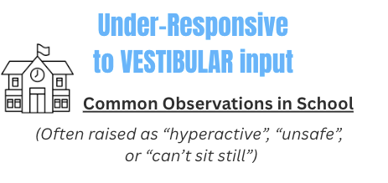  Seeks constant movement (jumping, rocking, spinning)  Struggles to remain seated during lessons  Takes physical risks without noticing danger  Appears more settled after PE or active play  Appears unaware of dizziness or spinning too much  Leans on walls, furniture, or other people for support when standing or sitting  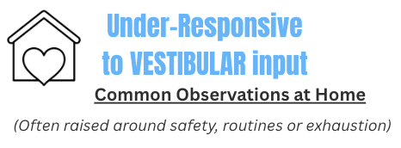  Constantly climbs furniture or jumps off surfaces  Seeks fast or intense movement (running, crashing, jumping, spinning)  Finds it hard to calm down without physical activity  Appears tired but still seeks movement  Difficulties remaining seated during meals, homework or family activities (e.g. repeatedly getting up, fidgeting, finding reasons to leave the table)
VESTIBULAR/MOVEMENT Preferences | VESTIBULAR/ MOVEMENT Challenges
- Calming/preferred movement  - Childs favourite physical activities  - Seeks more of..  Write movement preferences here... | - Triggers  - Avoids  - Most disliked movement  - OR – what situations feel difficult for the child due to lack of movement?  Write movement challenges here...
Because of Vestibular Sensory needs, this child currently struggles with…
Vestibular needs impact learning and participation in school
Vestibular needs impact self-care or independence at home
Vestibular needs impact emotional regulation
Vestibular needs appear masked in school
Vestibular needs are not currently a priority (they may exist, but not impacting daily function)
Appears to present over-responsive to Vestibular input
Appears to present under-responsive to Vestibular input
When Are These Needs Most Noticeable?
Vestibular responses (movement and balance) can vary depending on transitions, changes in pace, environmental movement and levels of predictability. Consider when difficulties with balance, movement or motion tolerance increase or reduce, and what this may suggest about environmental demands or regulation.
More noticeable during:
(Select and add additional context as needed:) Transitions/ Busy environments/ Lining up/ sudden movement/ routines changing unexpectedly/ After a dysregulating event earlier in the day/ When rushed or under time pressure/ When tired
Less noticeable when:
(Select and add additional context as needed:) Routines are predictable/ Transitions are clearly signposted/ Movement expectations are explained in advance/ Adult support is close/ The child feels safe/ Movement is self-directed and controlled/ There is space to move safely/ Activities are repetitive


PROPRIOCEPTION SENSORY SCREENING

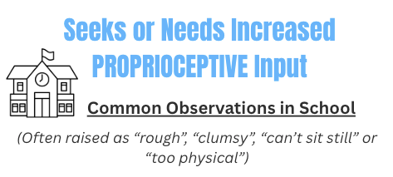  Uses too much or too little force (presses too hard with pencils, slams doors, bumps into others)  Appears clumsy or frequently bumps into furniture or peers  Finds it hard to sit still at the table or on the carpet  Seeks physical contact (leaning on others, crashing into cushions, hugging tightly)  Appears more regulated after PE or active play  Difficulty judging personal space  Struggles with handwriting or fine motor tasks due to poor force control  Chews on pens, hoodie strings, sleeves, collars, or other items constantly  Puts objects in mouth / mouths items (especially when concentrating or stressed)  Picks at skin, nails, cuticles, scabs, or pulls at hair during learning  Tears paper, fiddles with Blu Tack, rubs erasers, snaps rulers (seeking resistance/force)  Constantly taps, squeezes, presses, or leans heavily on the table/body)  Becomes more “chewy/picky/fiddly” during tricky thinking, writing, or when stressed  Uses too much force (heavy-handed writing, slamming doors, bumping into others)  Likes sitting pressed against walls, in corners, or wedged into small spaces  Appears calmer when wearing tight or snug clothing (leggings, hoodies pulled tight) | 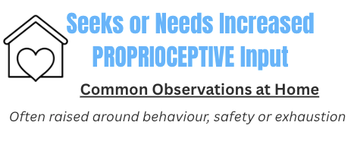  Seeks crashing, jumping, squeezing or rough play  Uses too much force during play or daily activities  Finds it hard to calm down without physical input  Chews clothing, toys, fingers, or seeks crunchy/strong input at home  Picks at nails/skin or pulls at hair when watching TV, gaming, homework, or winding down  Chews/picks more during worry, transitions, or after school  Seeks strong hugs, squeezes, or being “squashed”  Wraps self tightly in blankets or prefers heavy covers  Crawls into small spaces (under tables, between sofa cushions, cupboards)  Crashes onto furniture or the floor to calm down  Accidently hurts others during play “doesn’t know their own strength”  Appears restless even when tired  Appears calmer when wearing tight or snug clothing (leggings, hoodies pulled tight)
Proprioceptive input (body awareness, deep pressure and muscle activity) is typically regulating for most children. Difficulties are more commonly linked to under-registration, force grading or a need for additional input rather than sensitivity.

Proprioceptive Input That Organises the Body | Signs the Body Needs More Input
- Calming or grounding activities (deep pressure, squeezing, pushing)  - Favourite heavy work activities  - Seeks more of..  Write proprioceptive preferences here... | - List any signs or observations here which mean the child is giving signals they are needing more input  Eg: chewing nails, picking skin, kicking objects, cracking knuckles  Write proprioceptive clues here...

Because of Proprioception Sensory needs, this child currently struggles with…
Proprioception needs impact learning and participation in school
Proprioception needs impact self-care or independence at home
Proprioception needs impact emotional regulation
Proprioception needs appear masked in school
Proprioception needs are not currently a priority (they may exist, but not impacting daily function)
Appears to need more Proprioceptive input
When Are These Needs Most Noticeable?
Proprioceptive responses (body awareness, muscle input and force control) can vary depending on movement opportunities, environmental demands and levels of fatigue or stress. Consider when difficulties with body awareness, force grading or movement-seeking behaviours increase or reduce, and what this may suggest about regulation or access to organising input.
More noticeable during:
(Select and add additional context as needed:) Long periods of seated work/ Carpet time or assemblies/ Busy transitions/ Fine motor tasks requiring controlled force (e.g. writing)/ After a dysregulating event earlier in the day/ When rushed or under time pressure/ When tired or at the end of the day/
Less noticeable when:
(Select and add additional context as needed:) Routines are predictable/ Transitions are predictable/ Movement expectations are explained in advance/ Adult support is close/ The child feels safe/ The pace of the day is structured/ Activities are repetitive



INTEROCEPTION SENSORY SCREENING

Interoception is how we notice signals from inside the body (e.g. hunger, thirst, needing the toilet, tiredness, temperature, pain, illness and emotions). Some signals may feel very loud or urgent, while others may be quiet or hard to notice. Children may experience different patterns across different body signals.
Notices hunger or thirst very quickly and becomes distressed  Appears anxious about feeling hungry or thirsty  Does not notice hunger or thirst until very dysregulated  Forgets to eat or drink without reminders |   Feels urgent need to use the toilet and worries about accidents  Asks repeatedly to use the toilet  Does not notice need until very urgent  Has accidents due to reduced awareness
  Becomes very distressed when tired  Appears hyper-aware of tiredness or discomfort  Appears unaware of tiredness until exhausted  Struggles to regulate energy levels |   Becomes very uncomfortable in heat or cold  Strong reactions to minor temperature changes  Appears unaware of being too hot or too cold  Does not adjust clothing appropriately
  Frequently reports physical discomfort (tummy ache, headache, feeling unwell)  Becomes highly distressed by minor physical sensations  Appears unaware of injury or pain  Does not recognise signs of illness until symptoms are severe |   Strong emotions escalate quickly  Hyper-focused on bodily sensations (heart, tummy, breathing)  Emotional reactions seem sudden or “out of the blue”  Finds it difficult to name feelings or body sensations

Because of Interoception Sensory needs, this child currently struggles with…
Interoception needs impact learning and participation in school
Interoception needs impact self-care or independence at home
Interoception needs impact emotional regulation
Interoception needs appear masked in school
Interoception needs are not currently a priority (they may exist, but not impacting daily function)
Appears to struggle with ‘quiet’ interoception signals
Appears to struggle with ‘loud’ interoception signals

When Are These Needs Most Noticeable?
Interoceptive awareness can vary depending on stress levels, fatigue, predictability and environmental demands. Consider when internal signals become more overwhelming or harder to notice.
Interoception difficulties are more noticeable during:
(Select and add additional context as needed:) Transitions/ Busy or demanding times/ After emotional stress/ When routines change/ When tired/ In unfamiliar environments/ child is busy or focused on something holding their attention
Interoception difficulties are less noticeable when:
(Select and add additional context as needed:) Routines are predictable/ Body check-ins are structured/ Adult responses are calm and consistent/ The child feels safe/ Physical needs are anticipated or prompted


MAKING SENSE OF WHAT YOU’VE NOTICED

What Patterns Stand Out?

Across all systems, the most noticeable patterns are:
Sensitivity to unpredictable environments  High need for movement or deep pressure  Reduced awareness of internal signals  Sensory needs increase with fatigue  Needs appear masked in school  Needs impact self-care  Needs impact emotional regulation  Needs impact learning | OR..  Write key patterns observed:......

Which Sensory Systems Are Currently Impacting Daily Function?
Select up to 3 priority areas:
Tactile
Visual
Auditory
Olfactory
Gustatory
Vestibular
Proprioception
Interoception

Where Is the Biggest Impact in the Day?
For children who experience cumulative sensory overwhelm, it can be helpful to identify the part of the day where regulation is most difficult. This is often the most effective place to begin making changes.
Morning routine (before school)
Journey into school
Coming into school
Morning Learning
Playtime/ Break
Lunchtime
Afternoon Learning
End of day transition to home
After school/ Evening Routine
Bedtime / sleep
Make comments here..

Identify the Top 3 Priority Needs

Choose 2–3 High-Impact Priorities
Supporting two or three high-impact sensory needs often improves regulation across the day. When regulation improves, other behaviours may reduce without needing direct intervention.
Start where:
- The impact is greatest
- The child experiences most distress
- The environment can be adapted quickly
Small environmental shifts often create significant change.

Priority 1:
What is the specific sensory need? | (e.g. auditory overwhelm during lunchtime)
When does it happen most? | (Be specific: part of day, setting, trigger)
What is the impact? | (e.g. refusal, shutdown, aggression, anxiety)
What small environmental change or strategy will you trial first? | Use the Sensory Strategies Library for ideas..
What will “improvement” look like? | What will the child be able to do differently..
How will you know it is working? | What might be the signs you notice the strategy is working?..
Target review date: | 01/01/26

Priority 2:
What is the specific sensory need? | (e.g. auditory overwhelm during lunchtime)
When does it happen most? | (Be specific: part of day, setting, trigger)
What is the impact? | (e.g. refusal, shutdown, aggression, anxiety)
What small environmental change or strategy will you trial first? | Use the Sensory Strategies Library for ideas..
What will “improvement” look like? | What will the child be able to do differently..
How will you know it is working? | What might be the signs you notice the strategy is working?..
Target review date: | 01/01/26

Priority 3:
What is the specific sensory need? | (e.g. auditory overwhelm during lunchtime)
When does it happen most? | (Be specific: part of day, setting, trigger)
What is the impact? | (e.g. refusal, shutdown, aggression, anxiety)
What small environmental change or strategy will you trial first? | Use the Sensory Strategies Library for ideas..
What will “improvement” look like? | What will the child be able to do differently..
How will you know it is working? | What might be the signs you notice the strategy is working?..
Target review date: | 01/01/26

