Bowel Functioning

Normal Bowel Functioning

Food and fluid pass from the mouth into the stomach and then into the intestines. All the goodness is absorbed into the bloodstream. As the food passes through the large intestine, most of the water is absorbed back into the body, leaving solid, formed poo in the rectum. When enough poo collects in the rectum, messages are sent from the nerves up to the brain and we get the urge to go to the toilet. We can then choose whether to go immediately or hold it until a more convenient time. If we choose to go later, the urge to go wears off after a few minutes.

Normal Development of Bowel Control

Babies have no control over their bowels. As soon as the rectum gets to a certain level of fullness the muscle around the anus relaxes and it empties automatically. Toddlers start to recognise this sensation of fullness and start to use their pelvic floor muscles to hang on to the poo until they get to their potty. This takes a lot of practice so accidents are frequent at this time. As the child grows, the brain starts to take over this control so they no longer have to hang on using their pelvic floor muscles. The anal muscles stay tightly shut until they sit on the toilet and consciously relax.

What Can Go Wrong?

Problems start when the process of digestion speeds up or slows down. When digestion speeds up, the food moves through too quickly. Not enough fluid is absorbed and we get diarrhoea. When digestion slows down, the food moves through too slowly. Too much fluid is absorbed and the poo becomes very hard. It stretches the rectum, fresh poo leaks round it, and when we do manage to push it out, it can be painful. Holding on to poo for too long can also cause similar problems
What Makes It Speed Up Or Slow Down?

There are three main causes:
- Physical illness
- Poor diet
- Stress

Physical Illness
When we eat something that isn’t good for us, or we get a virus, it makes sense for the body to get rid of it as soon as possible, hence the digestive system speeds up and we get diarrhoea. When we are physically unwell, we often spend a lot of time resting which can cause our bowels to become sluggish which can lead to constipation. Medication can also cause the bowel to speed up (antibiotics can sometimes give us diarrhoea) or slow down (painkillers often make us constipated).

Diet
Fibre makes the poo bulky which helps the intestines to push it along. Fruit, vegetables and fluid make the poo moist and slippery which also helps it along. A diet that lacks these essentials can mean small hard pieces of poo which collect in the bowel and are painful to pass. A diet that is high in fat can also slow the bowel down.

Stress
When we get stressed the body produces chemicals which prepare it to escape danger. These chemicals make the heart beat faster and the lungs work harder. Parts of the bowel may speed up and other parts may slow down to help us to deal with danger. Some people are more prone to this than others: how our body deals with stress is usually genetic. The last part of the large intestine may contract to push as much poo as possible into the rectum so it can be passed quickly to make us lighter and more efficient, whereas the rest of the bowel may slow down to save energy.
What Happens When We Get Severely Constipated?

Hard lumps of poo collect in the rectum and more fluid is absorbed into the body so the poo becomes increasingly hard. Children become very frightened about the pain so they hang on. The urge to poo wears off after a few minutes so the child thinks they don’t need to go anymore. Some children get so practiced at hanging on (which is a natural instinct) that they can go for weeks without passing any of this hard poo. During this time the new poo is going through the system – some of it banks up behind the old poo and starts to dry out, and some of it leaks through.

As the poo builds up, it pushes the muscles in the rectum out of shape and the nerves become much less sensitive. Hence, the very runny liquid poo leaks out sometimes without the child having any control over it. At this stage you might think your child has diarrhoea, but it is actually overflow constipation – soft liquid poo leaking out leaving a backlog of solid, rock hard poo in the rectum and sometimes in the large intestine as well.

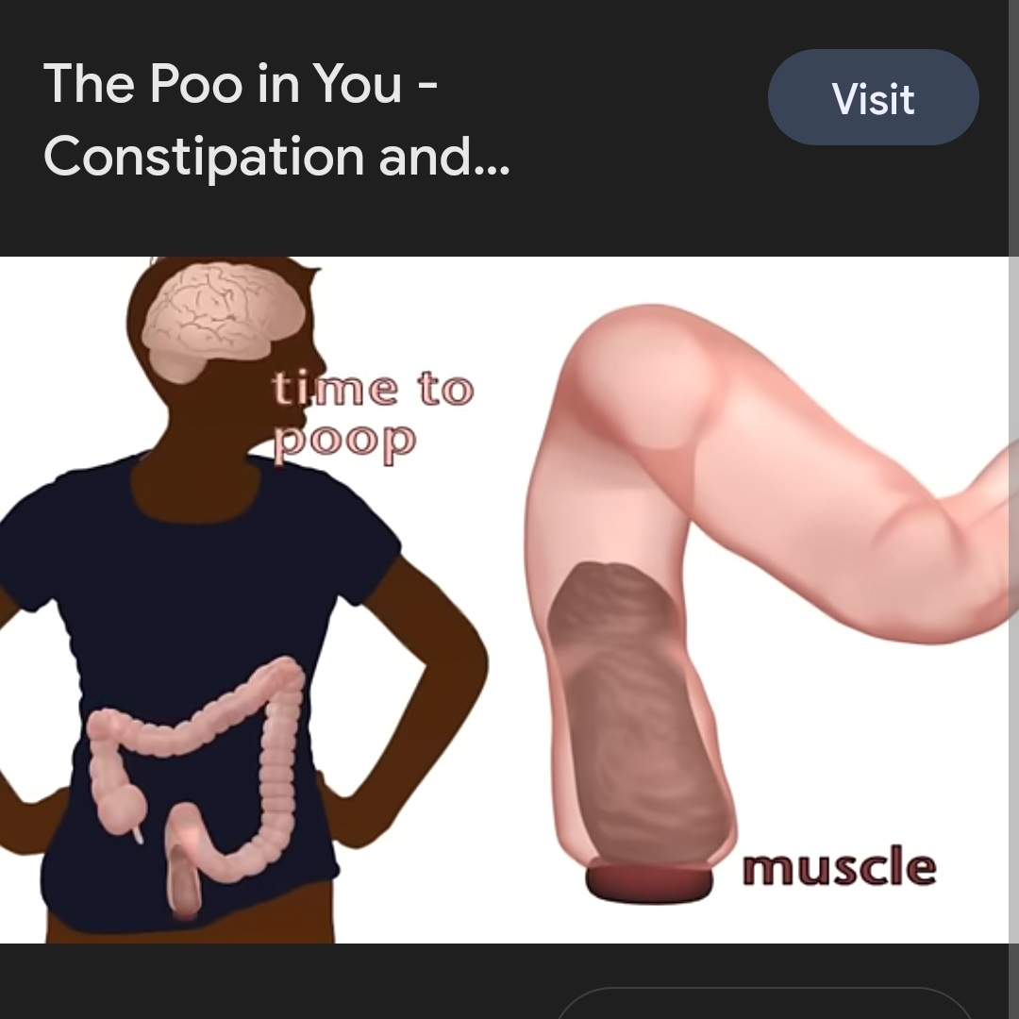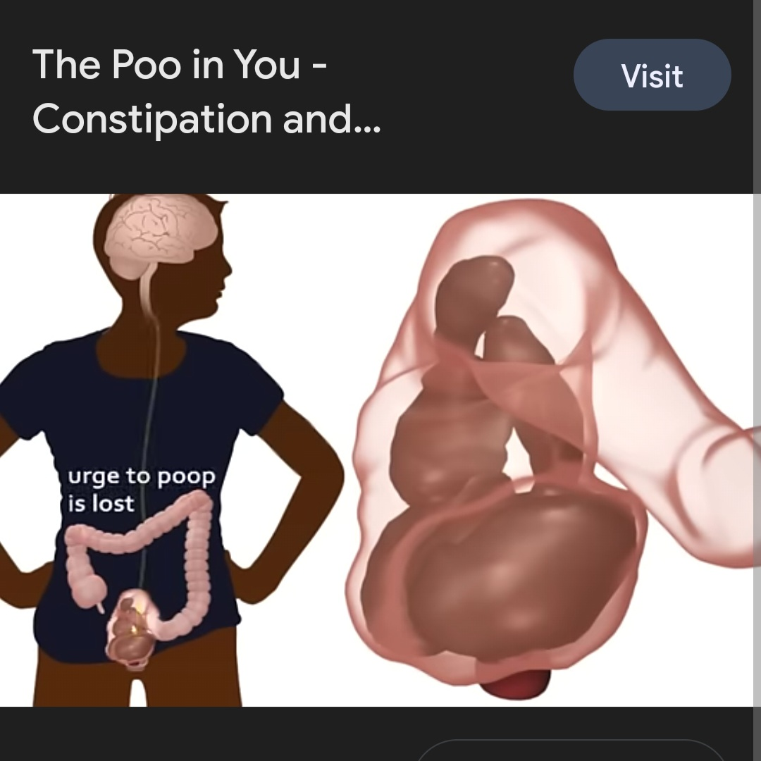

A Healthy Bowel A Constipated Bowel

For an excellent short video about this, watch The Poo in You - Constipation and Encopresis Educational Video (YouTube)

I Thought My Child Was The Only One

- GP’s see 6.3 patients a week with constipation which adds up to 200,000 appointments a week costing the NHS £9 million a week.

- 76929 people are admitted to hospital every year in the UK with a final diagnosis of constipation (211 people a day) costing the NHS £168 million per year.

- 13847 (18%) of these admissions were children (38 children a day).

- 1 in 12 children have a bowel or bladder condition.

- 1 in 3 children are affected by constipation.

- 30% of children experience acute constipation for up to 6 months and 5% develop chronic constipation (lasting longer than 6 months).

- 18% of toddlers have constipation.

- 14% of children and teenagers have constipation.

- Boys are affected 3-6 times more than girls.

- 25% of children who have bowel problems also wet themselves, probably due to pressure on the bladder from the distended bowel.

- Constipation is the most common gastrointestinal disorder making up 25% of referrals to a paediatric gastroenterologist.

- Soiling is one of the most common problems doctors see in children (20% of children who soil do not have constipation).

